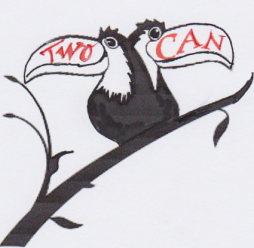
TwoCan Youth Theatre
Individual Information Form 2019/ 2020
University of Gloucestershire
Please remember that it is the responsibility of parents/guardians to ensure that TwoCan is kept informed of any changes to the details requested below. All data will be held confidentially.

Name of young person

Address:
Postcode:

Telephone Number(s):
(personal mobile if applicable)
Date of Birth:

E-mail

Age:

Name of School college / employment in September 2019

Any special needs/medical or other relevant info that will help participation and enjoyment during the sessions:
How did you hear about the youth theatre?

What was it that attracted you to sign up?

Details of parent/guardian
Name:

Relationship to child/young person:

E mail:

In the event of TwoCan being unable to contact the person named above in an emergency, please nominate a second responsible adult who we could contact: | Name  Contact number (s):  Relationship to child/young person:
I give permission for TwoCan to share our names and contact details with Active Impact who co-ordinate the whole ‘OF COURSE WE CAN’ programme and speak to a sample of parents after events. They may also from time to time contact you with information in relation to other opportunities/ short breaks and possible research into related matters that they think may be of interest or improve short breaks.

I understand that this information will be shared with Gloucestershire County Council , who provide funding for our holiday programme, so they can evaluate the service and plan for the future. I also understand that TwoCan may share information about my child with other providers of the OF COURSE WE CAN events as appropriate to ensure the safe inclusion of all children and young people of OF COURSE WE CAN events.

Signature of parent / guardian ……………………………………………….

All your information is treated with respect and complies with our duties in relation to GDPR2019. If you would like more information please contact Caroline Eardley at Active on 01452 298337 or Caroline@activeimapct.org.uk
Permission for use of photographs and video photograph
We require parental/guardian permission for any photographs or video photography that we undertake for promotional, educational or merchandising purposes. Signing the declaration below gives your consent for your child to be photographed or filmed in any TwoCan production or workshop.
I consent to my child/ward being photographed or filmed for the purposes outlined above:

Signature of parent/guardian

