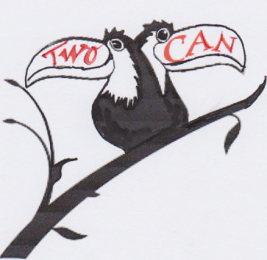
TwoCan Youth Theatre
Individual Information Form 2016/17

Please remember that it is the responsibility of parents/guardians to ensure that TwoCan is kept informed of any changes to the details requested below. All data will be held confidentially.

Name of young person

Address:
Postcode:

Telephone Number(s):
(personal mobile if applicable)
Date of Birth:

E-mail

Age:

School Year Group in September 2016
Any special needs/medical or other relevant info that will help participation and enjoyment during the sessions:
Name of school or college:

How did you hear about the Youth Theatre?

What was it that attracted you to sign up?

Details of parent/guardian
Name:

Relationship to child/young person:

E mail:

In the event of TwoCan being unable to contact the person named above in an emergency, please nominate a second responsible adult who we could contact: | Name  Contact number (s):  Relationship to child/young person:
Permission for use of photographs and video photograph
We require parental/guardian permission for any photographs or video photography that we undertake for promotional, educational or merchandising purposes. Signing the declaration below gives your consent for your child to be photographed or filmed in any TwoCan production or workshop.
I consent to my child/ward being photographed or filmed for the purposes outlined above:

Signature of parent/guardian

